# Define and Backtest a Simple Strategy

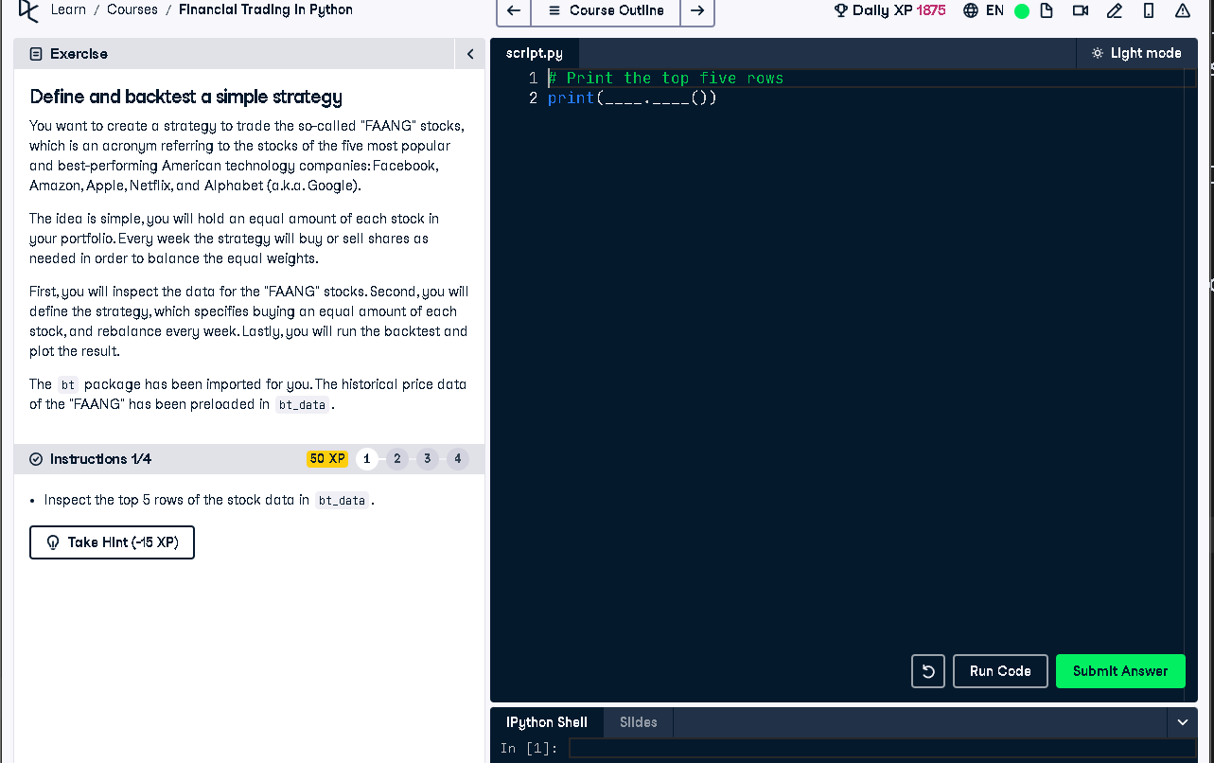

## Python Code

# Print the top five rows  
print(bt_data.head())

## Explanation (50 Words)

To begin backtesting the FAANG strategy, we first inspect the top 5 rows of the historical price data stored in `bt_data`.   
This helps ensure the dataset is correctly loaded and formatted before we define the strategy and proceed with rebalancing   
and testing portfolio performance.